Unix Programming Assignment - Week 12
Submitted by: Nisarga Vishwamanjuswamy

11.1 – serverpizza.c, clientpizza.c
Steps:
- Server Initialization: (first terminal)
- Hosts a menu.
- Allows the client to add multiple items to an order.
- Calculates the total cost.
- Responds to client messages with appropriate feedback (e.g., confirmation, error messages).
- Client Interaction: (second terminal)
- Connects to the server.
- Receives the menu.
- Sends item selections or a "done" message to complete the order.
- Receives order updates and a final summary.
- Finalization: ( interaction from second to first terminal)
- Once the client sends "done," the server calculates the total and sends a final message.
- The server and client close the connection.
To conclude with the implementation:
- Complicated Protocol: The code simulates a real-world pizza-ordering interaction with multiple steps for selecting items, looping for multiple additions, and finalizing the order.
- Client-Server Communication: The server sends the menu to the client, accepts client responses, and maintains a state for the current order.
- Loop for Multiple Items: The client can add multiple items through a loop until they indicate the order is complete ("done").
- Message Sequence:
- Server sends the menu.
- Client sends item numbers.
- Server confirms and updates the total.
- Client sends "done" to complete the process, and the server sends the final bill.
OUTPUT:
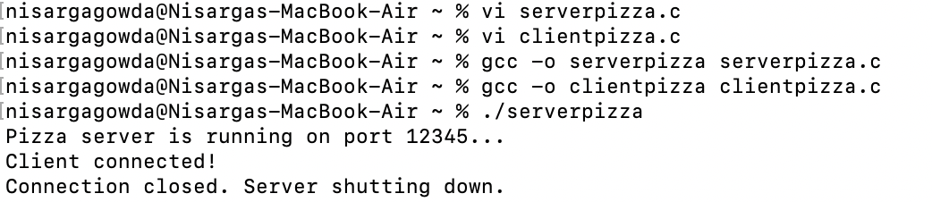

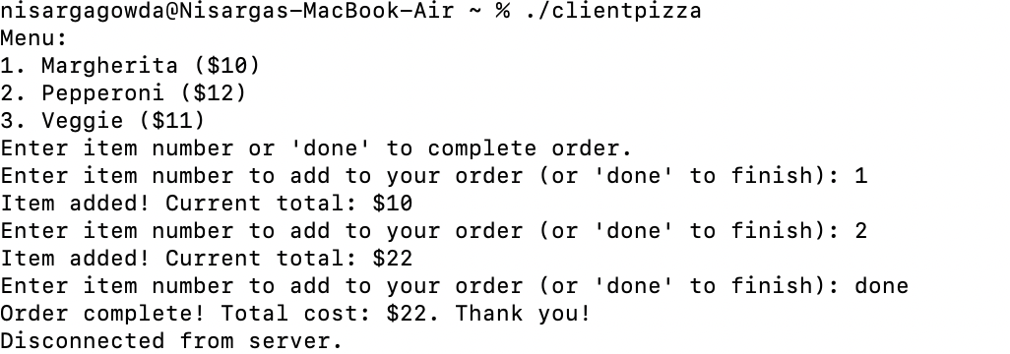

11.4. server.c, client.c
- Sockets and files both support standard file operations like read, write, and close, but they differ in key ways.
- Sockets enable communication between processes over a network, either locally or across systems, whereas files are used for local data storage.
- Unlike files, which are unidirectional, sockets support bidirectional communication, allowing real-time data exchange.
- Sockets also support connection-oriented (TCP) and connectionless (UDP) modes, while files are fixed in nature.
- Additionally, sockets have unique features like timeouts, non-blocking I/O, and configurable options (e.g., buffer size, keepalive), which are not applicable to standard files.
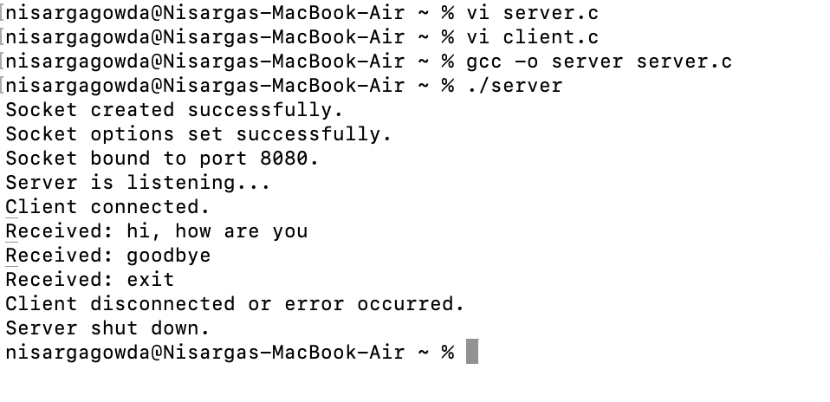
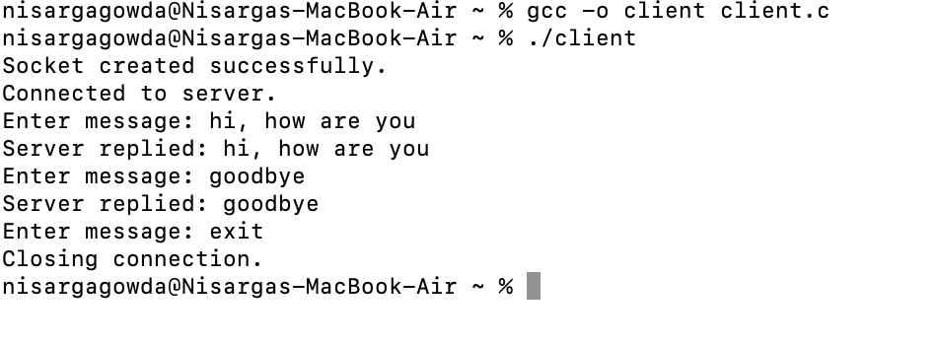
11.12 – timeserv.c, allowed_ip.txt

To implement IP blocking in a server, the server first checks the client's IP address upon receiving a connection.
If the IP is not in the predefined list of allowed IPs, the server closes the connection. The list of acceptable IPs can be stored in a file, which the server reads at runtime, allowing easy updates without modifying the code.
This feature enhances security by ensuring that only trusted clients can access the service.
Practical applications include:
- Access Control for Sensitive Services- By restricting access to specific IP addresses, organizations can prevent unauthorized users from interacting with critical services, such as internal databases or financial systems, enhancing data security.
- Preventing DDoS Attacks- IP blocking can help mitigate Distributed Denial of Service (DDoS) attacks by filtering out traffic from suspicious or malicious IP addresses, ensuring the server remains functional for legitimate users.
- Geo-blocking for Regional Restrictions- Servers can block or allow access based on geographic locations, preventing users from regions where services are not available or where legal restrictions apply.
- Protecting Private Networks - For private networks or intranet services, IP blocking ensures that only devices within the organization’s network can access certain resources, preventing external threats.
OUTPUT:
